# Week 1

Analysis Framework

* 4 Levels:
  + Domain
    - Who are the target users?
    - A field of interest of the users
  + Task & Data abstraction
    - Data abstraction
      * What is shown?
    - Task abstraction
      * Why is the user looking at it?
  + Idiom
    - How is it shown?
    - How to draw? How to manipulate?
  + Algorithm
    - Efficient computation

Data attribute types:

* Categorical / Nominal / Qualitative
  + These attributes represent distinct categories or labels without any order
  + Eg. Gender, Colour, Country
* Ordered - Ordinal
  + These attributes have a meaningful order or ranking, but the exact differences between values are not well-defined
  + Eg. Education level (high school, bachelor’s, master’s), Customer satisfaction rating (low, medium, high), Socioeconomic status (low, middle, high)
* Ordered - Quantitative
  + These attributes represent numerical values with measurable quantities
  + Eg. Money, Degree Celsius, Coordinates

Trees & Network:

* Synonyms:
  + Network = Graph
  + Node = Vertex
  + Link = Edge

Actions: Search and Query

* Lookup: Location and targets are known
* Browse: Location is know, target is unknown
* Locate: Location is unknown, target is known
* Explore: Location and targets are unknown

Marks and Channels:

* Marks:
  + Geometric Primitives
  + Eg. Points, Lines, Areas
* Channels:
  + Control appearance of marks
  + These channels allow us to visually represent underlying data values effectively
  + Type of channels;
    - Position: position along a common scale to represent numerical values or colour to distinguish categories
    - Colour: different colours represents different categories
    - Shape: different shape represents different categories
    - Size: can be length or area
    - Volume
    - Tilt/Degree

Colour Channels

* Colour Hue
  + Hue represents the specific colour itself in a visual display
  + Eg. red, blue, green
* Colour Value
  + Colour Brightness
  + It represents the intensity of the colour, with higher values indicating lighter shades and lower values indicating darker shades
* Colour Saturation
  + Measures the purity or vividness of a colour
  + A fully saturated colour is vibrant and intense, while desaturated colours appear more muted or greyish

# Week 2

Vocabulary: Idiom, Graph, Plot, Diagram, Chart, Map

* Idiom: An idiom in data visualisation refers to a specific design pattern or visual representation that conveys information effectively. It’s like a visual language that communicates common concepts or relationships
  + Eg. Dot Plot, Bar Plot, Pie Chart
* Graph: A graph is a visual representation of data using nodes (vertices) and edges (connections). It’s commonly used for showing relationships, networks, or dependencies.
* Plot: A plot is a graphical representation of data points or values. It typically shows the relationship between two variables (e.g., x and y) using points, lines, or curves.
* Diagram: A diagram visually represents a system, process, or structure. It uses shapes, lines, and labels to convey information. Examples include flowcharts, organisational charts, and Venn diagrams.
* Chart: A chart is a specific type of visual representation that displays data using various graphical elements (such as bars, lines, or pie slices). Common chart types include bar charts, line charts, and pie charts.
* Maps: A map is a visual representation of geographic or spatial data. It shows the distribution of data across regions, countries, or areas. Maps can be thematic (showing specific attributes) or topographic (displaying physical features).

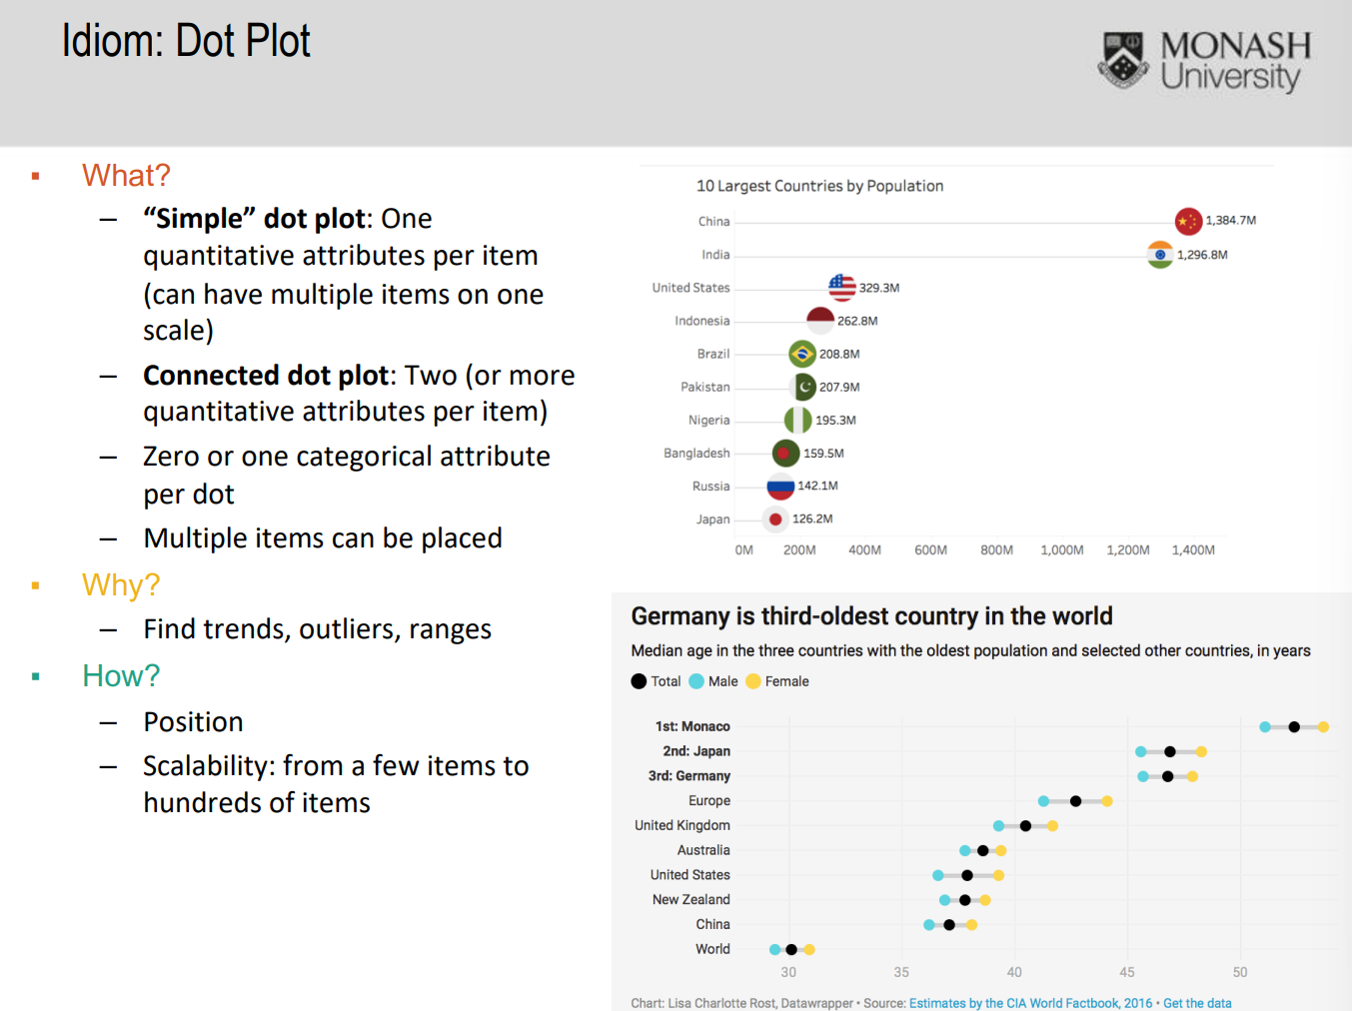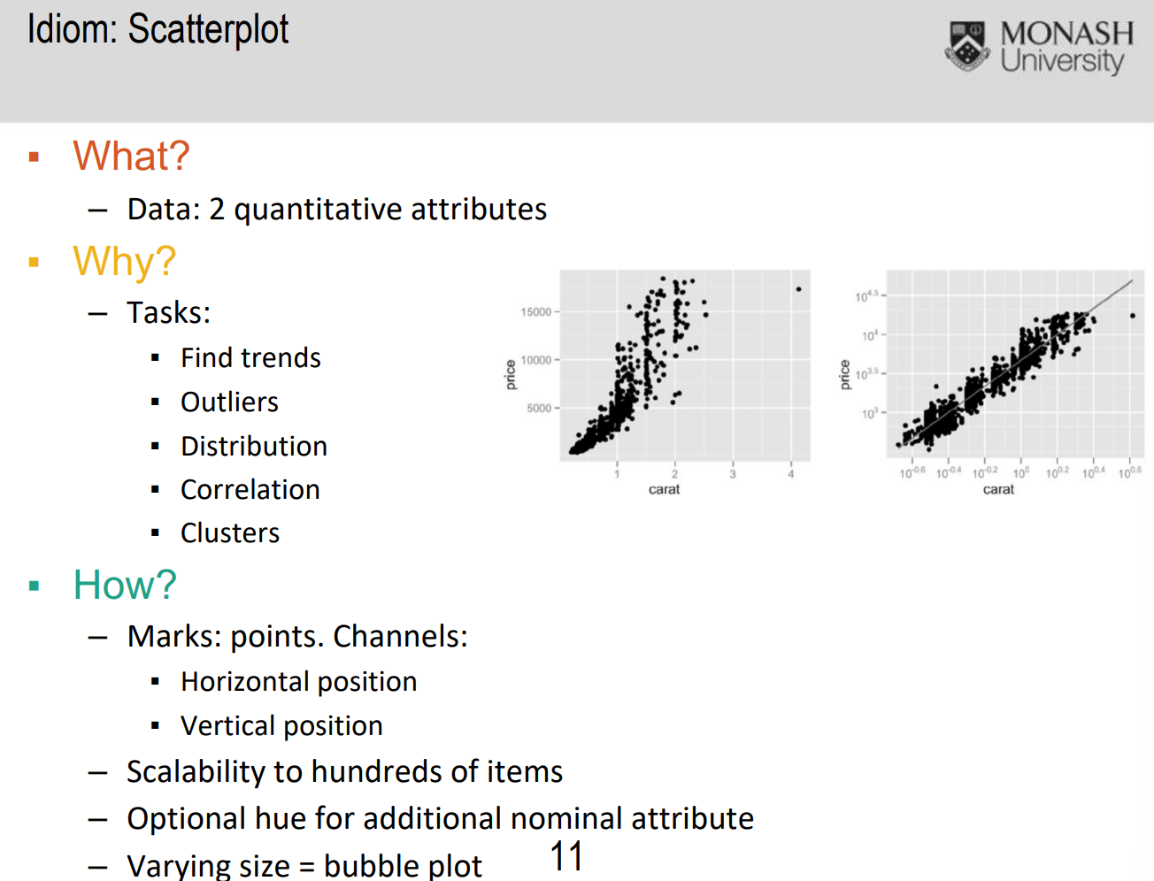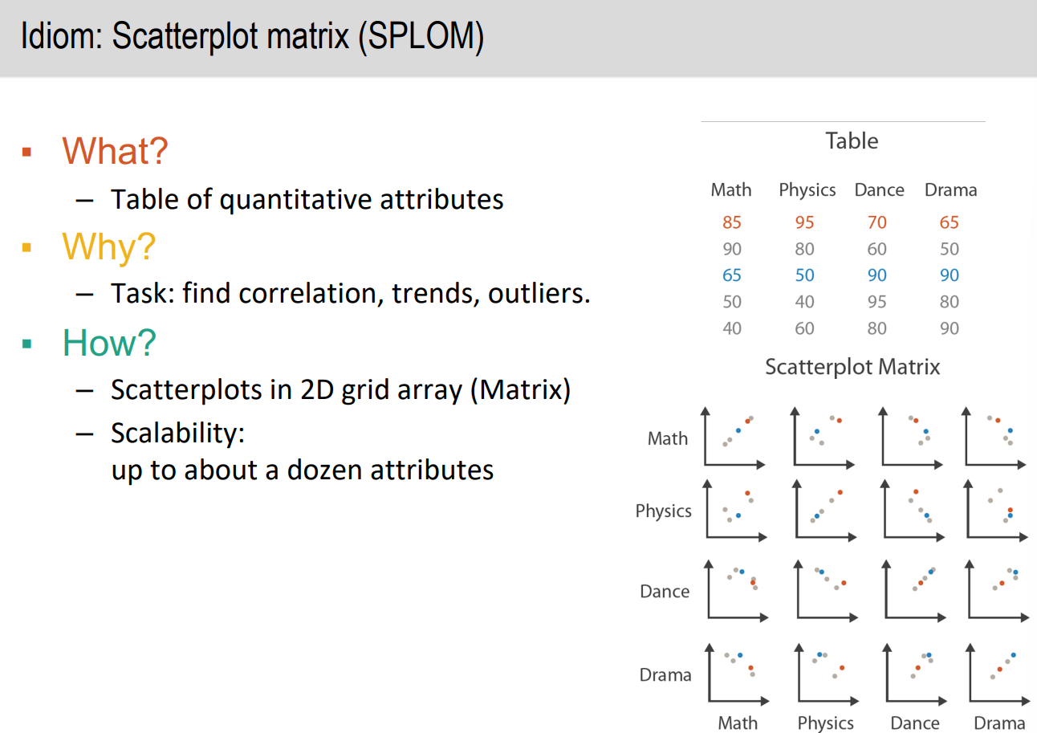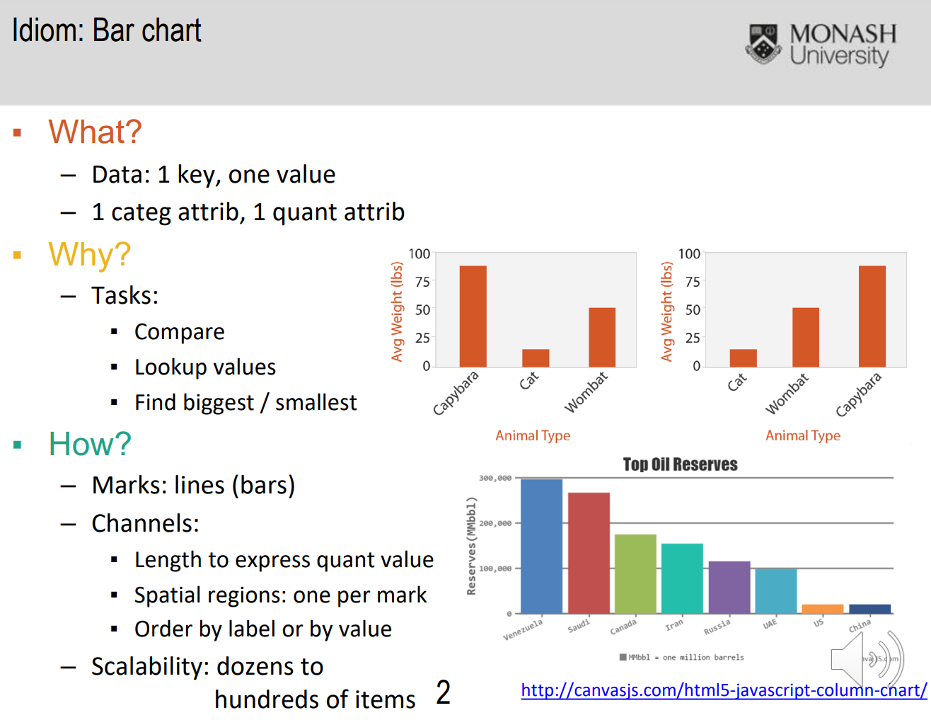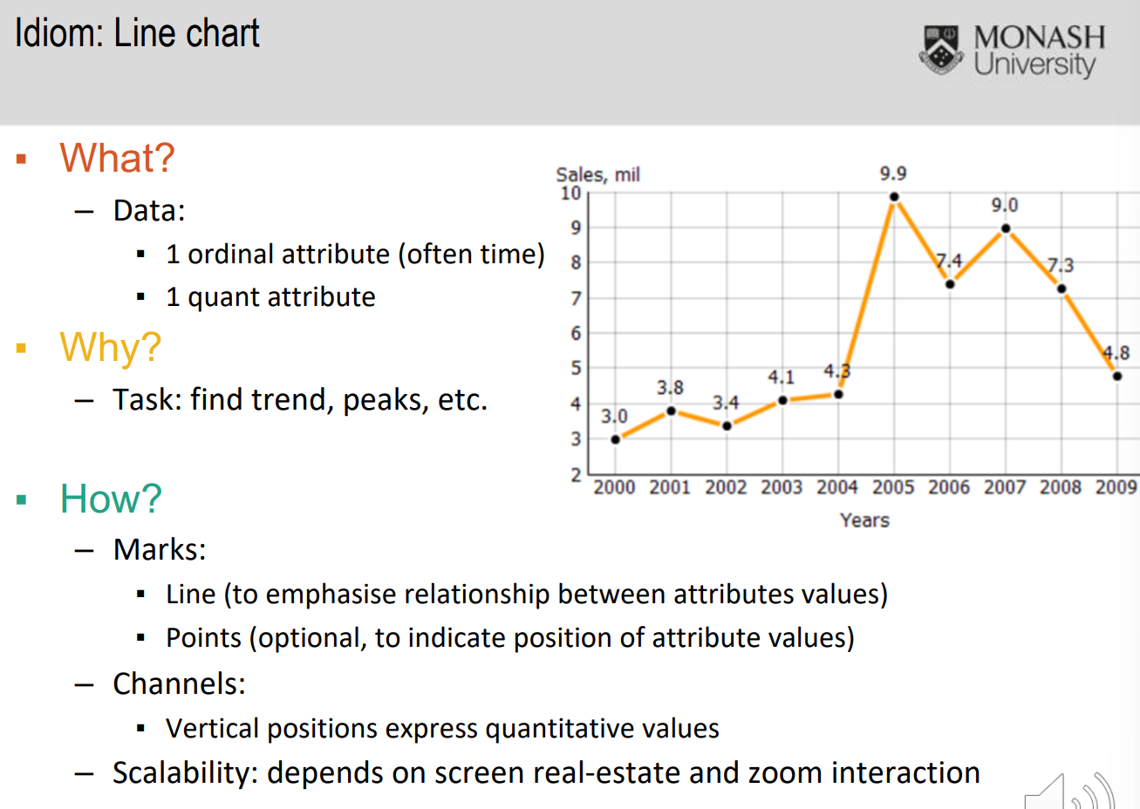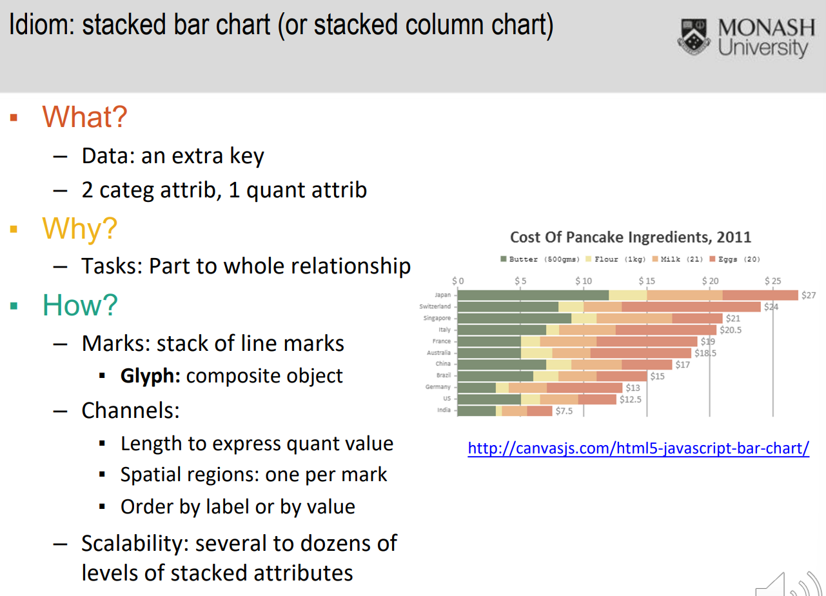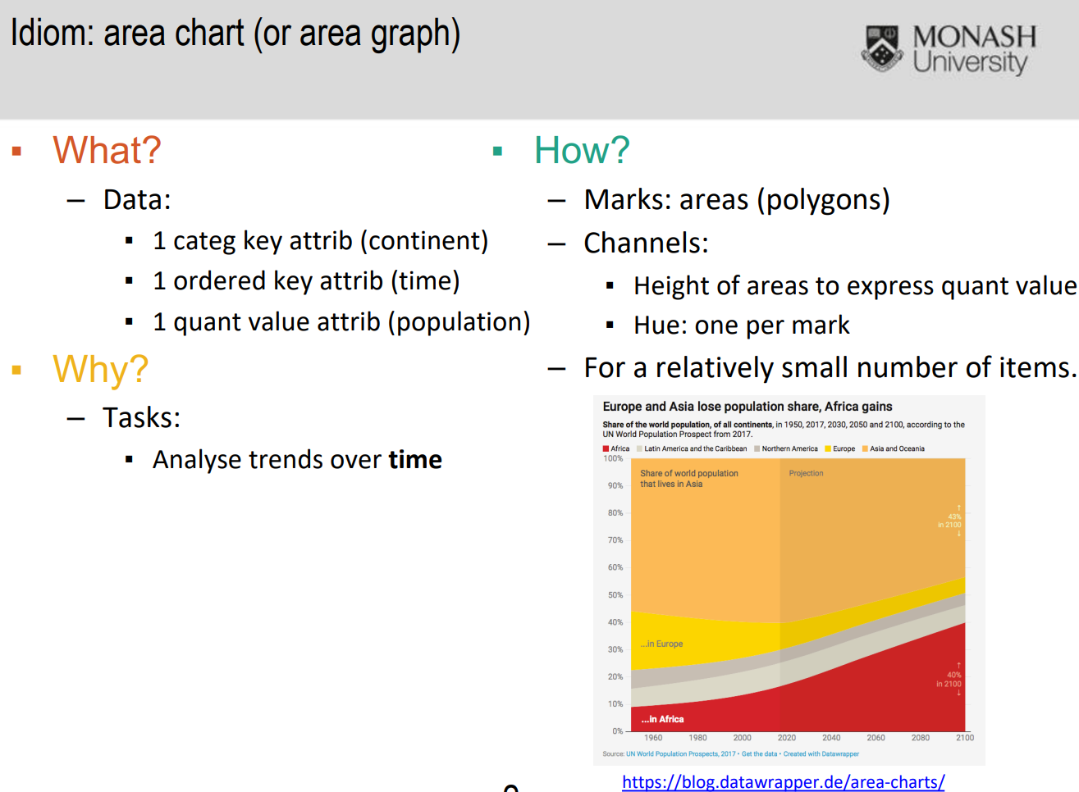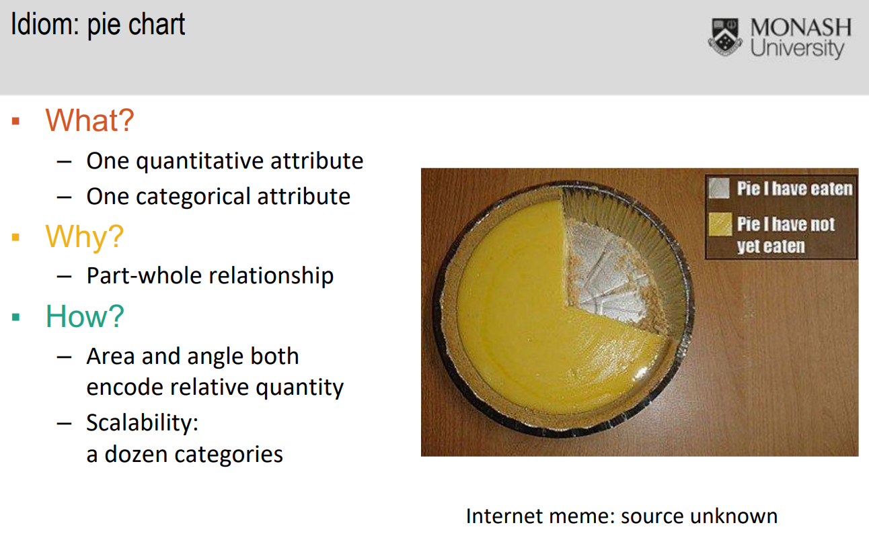

# Week 3

Data-Ink Ratio

* Measurement on amount of ink used to represent data in a ratio
* Should be best close to 1

ChartJunk

* Unnecessary and redundant elements used to create the chart
* Do not aid the understanding of date

Storytelling

* Guiding viewers through visualisation by controlling order of data seen
* Similar images, patterns, or colours humans will instinctively relate them tgt

Genres

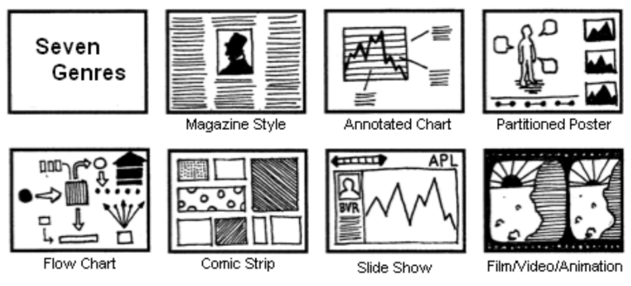

* Magazine Style
* Annotated Chart
* Partitioned Poster
* Flow Chart
* Comic Strip
* Slide Show
* Film/Video/Animation

Lying

* Chart displayed in absolute figures (units) instead of relative numbers (actual numbers like percentage)
* Chart displayed in accumulative figures instead of individual figures
  + Looks like growing trend but when shown in individual figures its actually not
* X or Y axis did not start from 0
* Total of pie chart is not 100%
* Nonexistent correlation

# Week 4

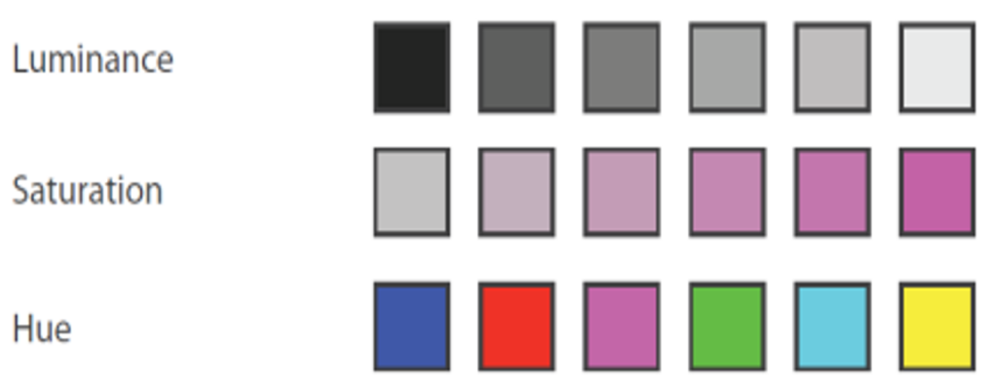

Avoid red and green colour due to 8% of male having colour blindness

Visual Hierarchy

* Apply figure ground to have hierarchy between visual elements

Figure Ground

* Visual depth for accentuating one object over another, based on the perception that one object stands in front of another and appears to be closer to the reader
* Figures: important objects, become objects of attention and stand out from the background
* Grounds: things less important, the background

Layout

* 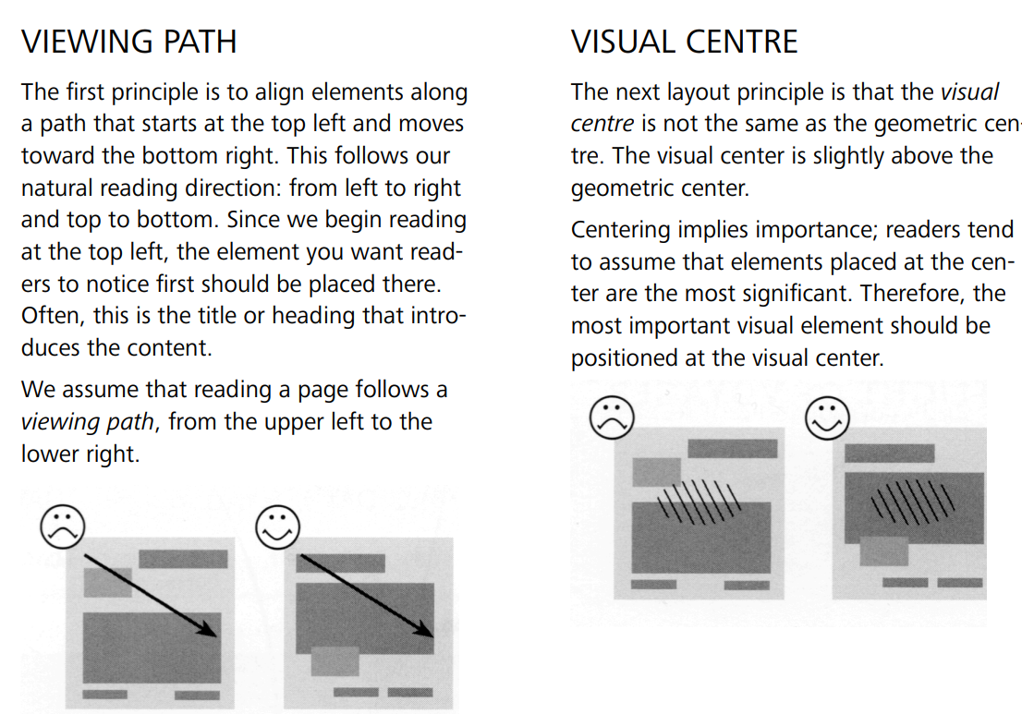
* 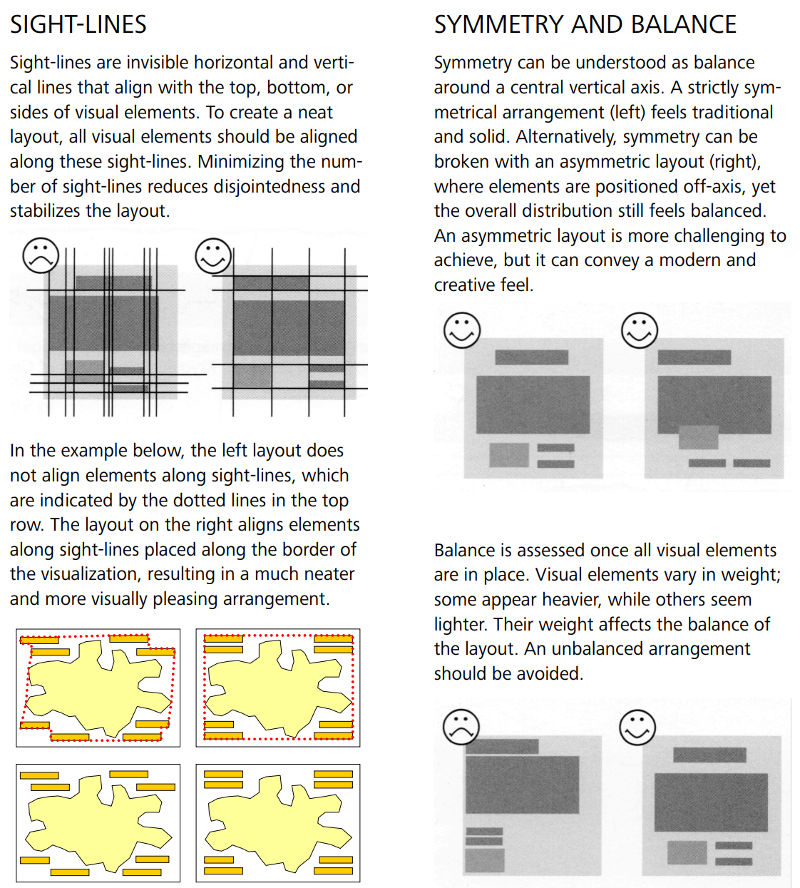
* 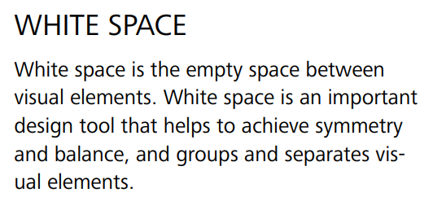

# Week 5

Table Idioms

* Venn Diagram / Set Diagram
* Proportional Symbol Chart / Packed Bubble Chart
* Word Cloud
* Dot Matrix Chart
* Waffle Chart
* Isotype
* Histogram
* Heatmap
* Box Plot
* Slope Chart
* Parallel Coordinate Plot
* Bump Chart
* Streamgraph
* Radar Chart
* Polar Area Chart
* Spiral Plot

Techniques to display repeating patterns

* Marks
* Overlaying time frames
* Aggregation
* Small multiples
* Animation

# 

# Week 6

Network and Tree Idioms

* Network / Node-Link Diagram
* Dendrogram
* Chord Diagram
* Alluvial Diagram
* Sankey Diagram
* Adjacency Matrix
* Treemap

| Charts / Diagram | Networks | Trees |
| --- | --- | --- |
| Node-Link Diagram | Yes | Yes |
| Adjacency Matrix | Yes | Yes |
| Enclosure | No | Yes |